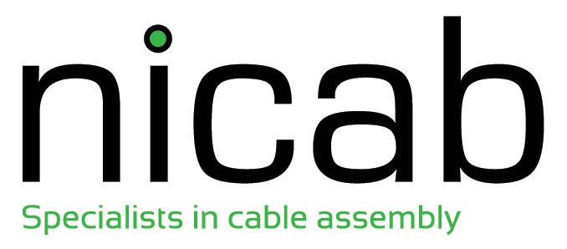

Anti-Bribery & Corruption Policy

Policy Statement

This policy applies to all persons working for us or on our behalf in any capacity, including employees at all levels, directors, officers, agency workers, seconded workers, volunteers, agents, contractors and suppliers.

Nicab Ltd strictly prohibits the use of bribery or in our operations and supply chain. We have and will continue to be committed to implementing systems and controls aimed at ensuring that bribery and corruption is not taking place anywhere within our organisation or in any of our supply chains. We expect that our suppliers will hold their own suppliers to the same high standards.

Commitments

Report any conduct that you believe to be a violation of this Policy, either directly to a member of the Serious Fraud Office (SFO) , to the Nicab Legal Department, or to Nicab’s Senior Management. All of which allow anonymous reporting as permitted by applicable law.

Employees who fail to report actual or suspected misconduct may be deemed in violation of this Policy as permitted by applicable law.

Nicab will not tolerate retaliation against an employee for reporting a concern in good faith or for cooperating with a compliance investigation, even when no evidence is found to substantiate the report.
Any violation of this Policy may be grounds for disciplinary action, up to and including termination, subject to applicable law.

Violation of applicable laws may also result in criminal prosecution of responsible individuals

Issue | Issue Date | Additions/Alterations | Initials
1.0 | 19th June 2017 | First release | NL

